**Precision, Accuracy, and Precipitation Reactions**

6 September 2023

CHEM 1310L Laboratory

*Data and Results*

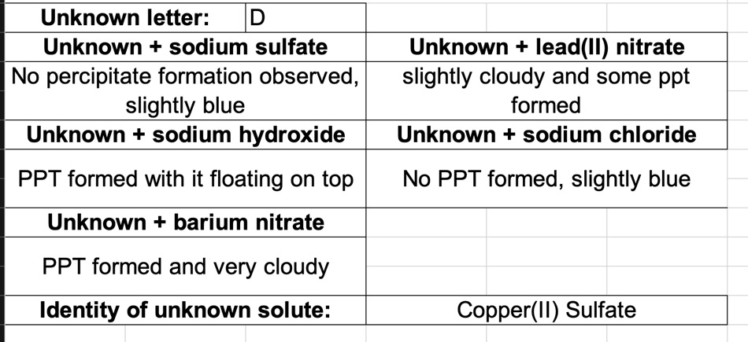

**Table 1.** Determination of the identity of an unknown solution of an ionic salt via precipitation reactions.

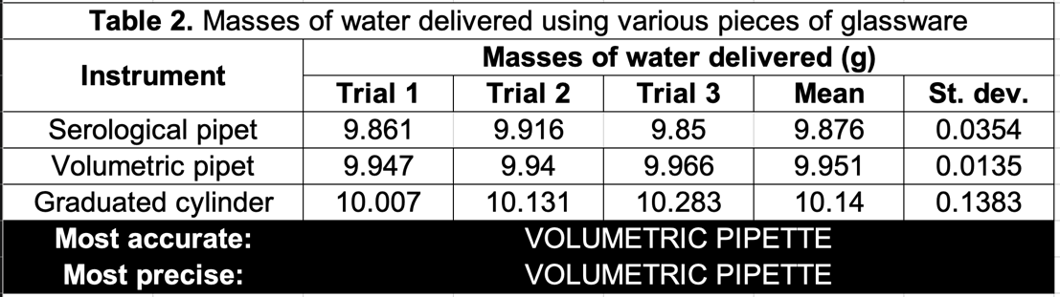

**Table 2.** Determination of precision and accuracy of laboratory glassware designed to deliver 10 mL of liquid.

**Figure 1.** Determining the rate at which temperature increases for a 50mL sample of water when kept over a 254 C˚ hot plate.

*Discussion*

Experiment 1

After mixing all individual known solutions with our unknown solution, my group and I used the series of solubility rules along with qualitative observations to to deduce what the solvent was. Consider our first solution, which was a mixture between our unknown solution and with aqueous Lead (II) Nitrate and also consider our second solution between barium nitrate and our unknown. Let the unknown solution be represented by the arbitrary chemical formula *AB* where A is the cation and B is the anion. The following is a model of the chemical reaction (double dissociation) that took place.

$$Pb{(NO_{3})}_{2}+AB →PbB+ANO_{3}$$

$$BaNO_{3}+AB →BaB+ANO_{3}$$

Because of solubility rule #1, any compound that contains Nitrate as the anion is automatically soluble, leaving *PbB*/BaB as the compound of the precipitate that formed in their respective mixtures during this reaction. Rule #4 leads us to believe that if B were to be sulfate, then it would be insoluble in water explaining the precipitate since sulfate is soluble except when paired with lead (II) or with barium. Consider the next mixture between our unknown solution and Sodium Hydroxide.

$$NaOH+AB →NaB+AOH$$

During this reaction, a precipitate had formed and according to rule #1 in the solubility rules, the precipitate formed cannot be *NaB* because all group 1 cations (sodium included) are soluble. Thus, the PPT formed must be *AOH*. Rule #5 of the solubility rules guarantees that A cannot be a group 1 cation because otherwise, it would make *AOH* a soluble compound. Because A cannot be a group 1 cation, we are left to decide between Copper (II) and Silver. In order to determine the cation for our solution, consider our final mixture between Sodium Sulfate and our unknown solution.

$${Na}_{2}SO_{4}+AB →NaB+ASO_{4}$$

Because the solution above did not produce a precipitate, cation A cannot be any of the following: barium, strontium, lead (II), calcium, silver, and mercury (I) as doing so with Sulfate would render it insoluble. And because *NaB* is automatically considered soluble by way of rule #1, cation A must pair with sulfate in order for it to remain soluble. As such, cation A is Copper (II). Thus, our unknown solution D is Copper (II) Sulfate:

$$CuSO_{4}$$

Experiment 2

Our ranking for most accurate to least accurate glassware in order to measure 10mL of water is as such:

1. Volumetric Pipette
2. Serological Pipette
3. Graduated Cylinder

Accuracy is a measure of how close the experimental data is to the theoretical or accepted value. Our accepted value was 10mL and the experimental values for each of piece of glassware are the averages across the three trials found above in Table 2. To compute how accurate experimental data is, we use the percent error as a way of comparing how far off or how inaccurate a piece of data is from the accepted value. The percent error for each piece of glassware is listed below.

1. Volumetric Pipette (~.49%)
2. Serological Pipette (~1.24%)
3. Graduated Cylinder (~1.4%)

As one would expect, the rankings of accuracy are solely dependent on the percent error.

As for ranking most precise to least precise, the rankings are as listed below:

1. Volumetric Pipette
2. Serological Pipette
3. Graduated Cylinder

To determine how precise a piece of glassware is, we measure how spread out the data is across every trial; we do this through calculating its standard deviation. The standard deviation values are listed below.

1. Volumetric Pipette (0.0135)
2. Serological Pipette (0.0345)
3. Graduated Cylinder (0.1383)

Analogous to accuracy, determining how precise a piece of glassware as it compares with others is determining which glassware carries the smallest standard deviation. Those with the smallest standard deviation illustrate data readings across trials that are very close to one another.

Experiment 3

Based on the specific heat of water (4.184) and the rate at which the temperature changes for the 50mL sample of water (.1488), found in the line graph above, we can figure out the average heating of the hot plate in joules per minute. Consider the dimensional analysis below.

$$4.184\frac{J}{g˚C}× 50 g × 0.1488\frac{˚C}{s} × \frac{60 s}{1 min}=1868\frac{J}{min}$$

We get 1868 joules per minute as the average heating of our hot plate.